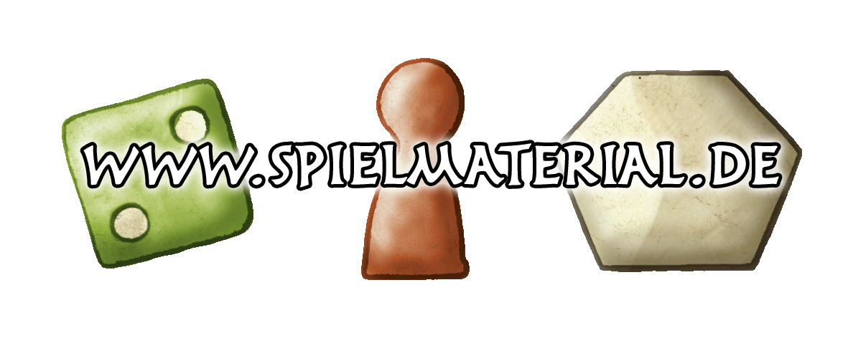
Cancellation Form
(If you wish to cancel this contract, please complete and submit this form)
- To:
Mücke Autorenrechte / www.spielmaterial.de
Inhaber: Harald Mücke
Pescher Str. 235
D-41065 Mönchengladbach /Germany
Telefon: +49-2161-9922982
Fax: +49-2161-9922981
E-Mail: info@spielmaterial.de
- I/We (*) hereby give notice that I/We (*) cancel my/our (*) contract of sale of the following goods (*)
- Bestellung Nr. ___________________________________________
- Ordered on (*)/received on (*) __________________________________________
- Name of the consumer(s) _________________________________________________
- Address of consumer(s) __________________________________________________
- Signature of cosumers (only if send by paper)
______________________________________________________________________________
- Date ________________________________________________________________________
- Way of payment return _______________________________________
_____________________________________________________________
(*) Delete as appropriate.

